Mr. Robot Writeup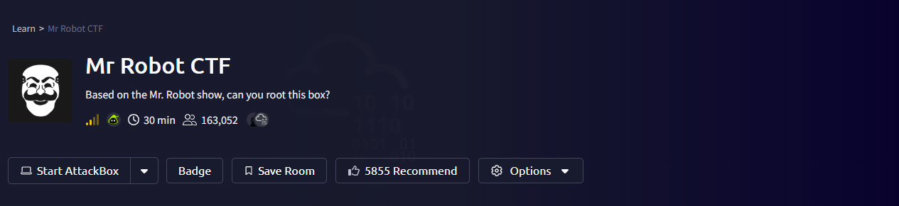
By: Malachi Plamann
Date: 11/14/2025
Link to CTF: https://tryhackme.com/room/mrrobot
Difficulty: Medium

Objectives:
- What is key 1?
  - 073403c8a58a1f80d943455fb30724b9
- What is Key 2?
  - 822c73956184f694993bede3eb39f959
- What is Key 3?
  - 04787ddef27c3dee1ee161b21670b4e4

Machine Info:
IP: 10.201.38.181
Hostname: robots.thm

Summary:

This machine is a great example of what can happen if file permissions are set incorrectly and if you aren’t aware of your attack surface. I was able to use a forgotten dev note with credentials to login to an admin dashboard, edit a template to allow a reverse shell, and exploit open file permissions with out of date password hashing to finally escalate privileges to root using an unnecessary set SUID permission on nmap.

Walkthrough:
Starting with a Nmap scan of the Hostname to view our initial attack surface
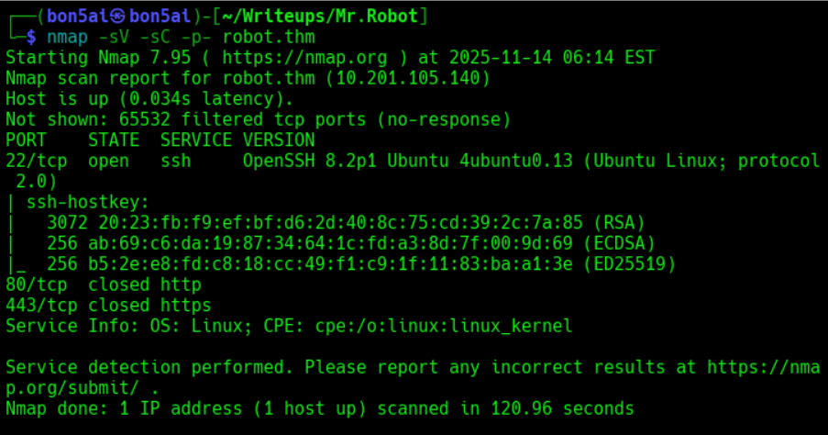
We have ports 22, 80, and 443 open
22 – SSH - OpenSSH 8.2p1 Ubuntu 4ubuntu0.13
80 – HTTP – Uknown Version
443 – HTTPS – Unknown Version
Let’s start by exploring the webpage
We are welcomed with a terminal with a list of validated commands we can run
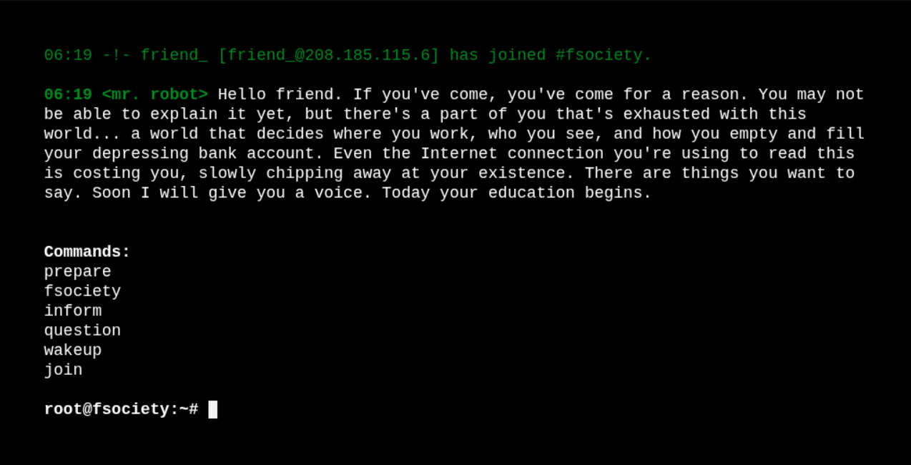
While we mess with the commands let’s start enumerating directories on the webpage using tools like gobuster and feroxbuster
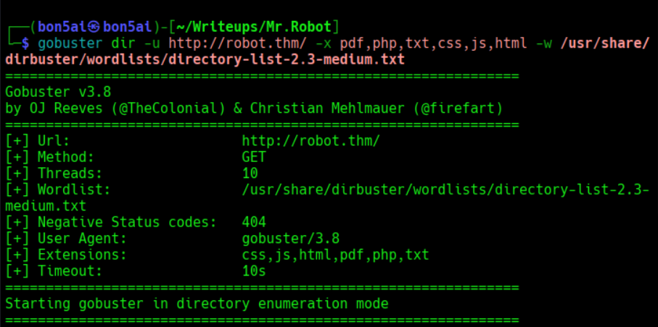
We find a few interesting directories to check out
/0 – Loads into a wordpress page
/robot.txt – Lists two allowed directives
/login – A wordpress login page
/license – Random statement on page
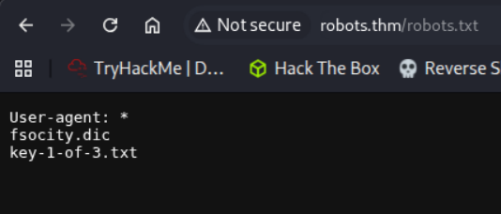
Let’s visit both of these directives to see what they contain
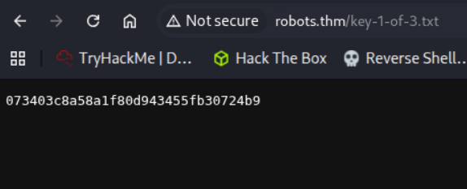
The /key-1-of-3.txt contained the first key needed to complete objective 1
/fsocity.dic contains a huge list of what looks like passwords we can use to brute force
Let’s save the .dic file to our local machine
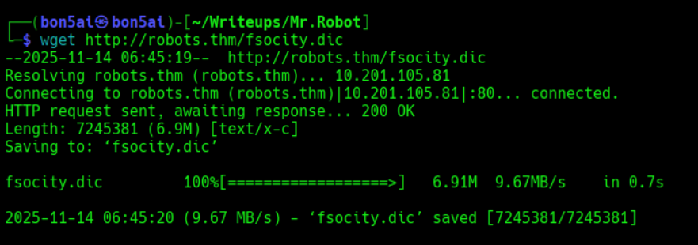
Let’s now visit /license again
Checking page source doesn’t show us anything but checking the inspect did!
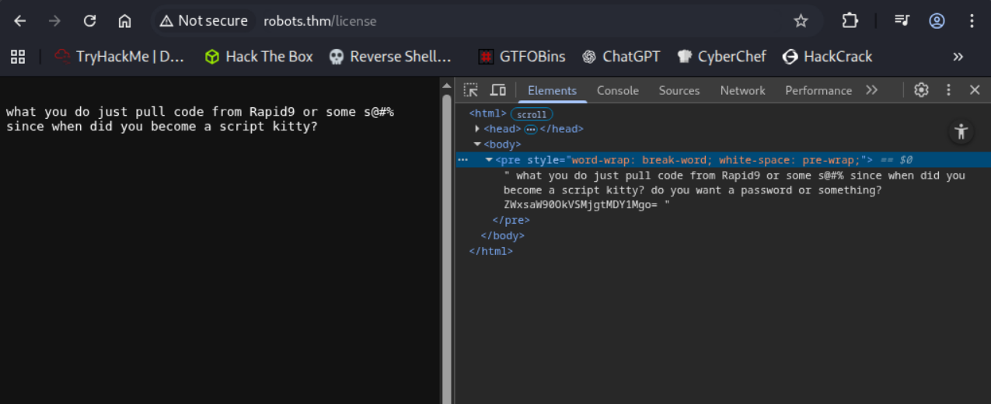
We have a base64 encoded value, Let’s decode it and see what we get
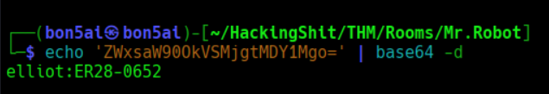
Interesting, Let’s try these credentials on both ssh and /login
SSH login did not work but we were able to login to the wordpress admin page!
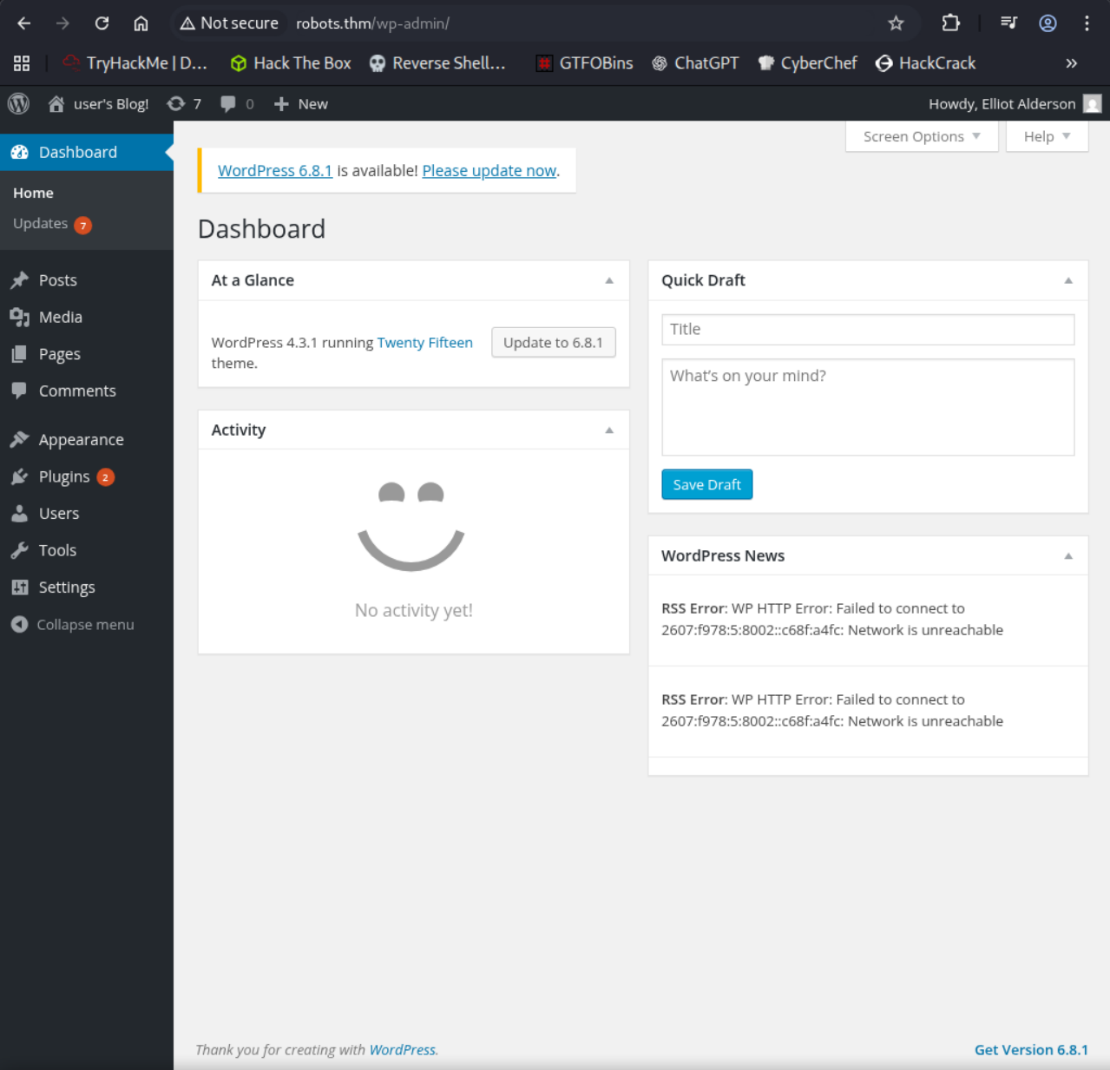
Let’s look around the webpage and see what we can mess with
Under Appearance > Editor we have access to edit page templates, including the 404.php page
Let’s copy and paste a php reverse shell into this template and see if we can get a shell by using the 404 template
Link to the php reverse shell script I used: https://github.com/pentestmonkey/php-reverse-shell/blob/master/php-reverse-shell.php

Here’s the template before we edit the script:
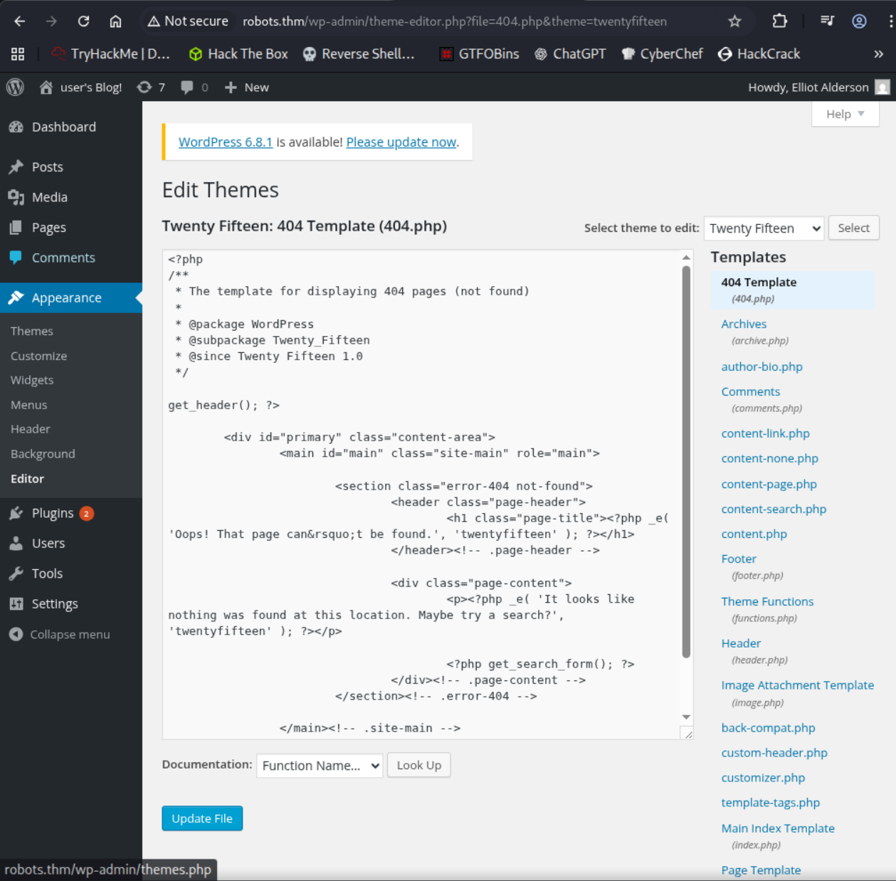
And now the template AFTER we edit the template script:
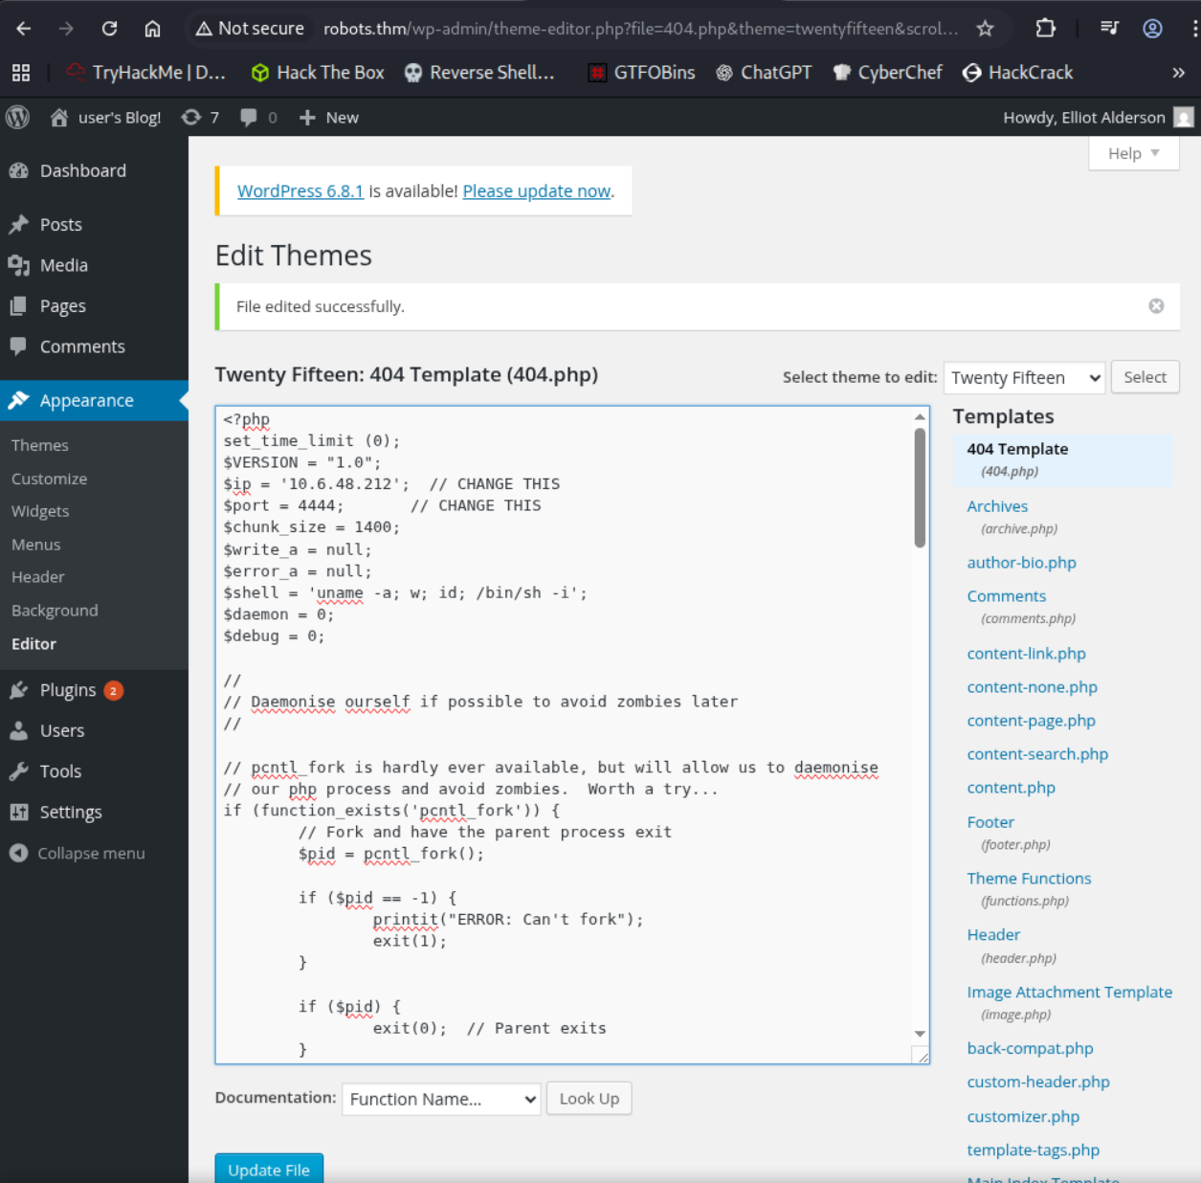
Now let’s setup a Netcat listener on the specified port in the php reverse shell
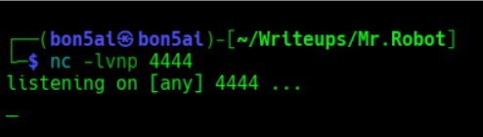
Now all we have to do is visit a webpage that would normally give us a 404 error
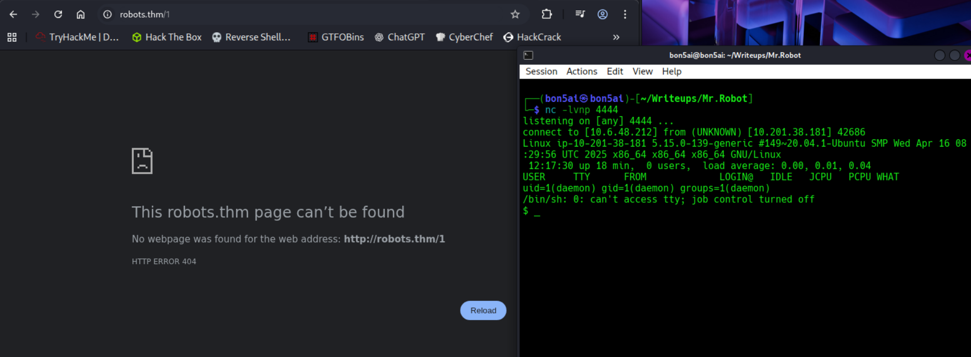
This worked because we were able to edit the php template for the 404 error and input our own malicious script. Once that 404 error was triggered our code was ran, granting us a reverse shell
Let’s explore the reverse shell
We have two users with home directories, robot and ubuntu
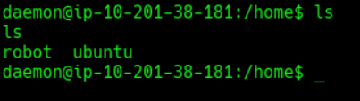
While exploring robot’s home directory I found the second key but we don’t have permission to view
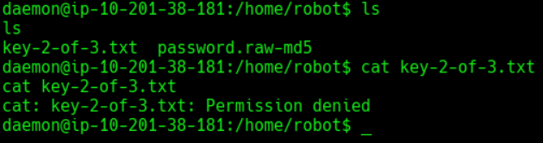
But we do have permission to view the password.raw-md5 file
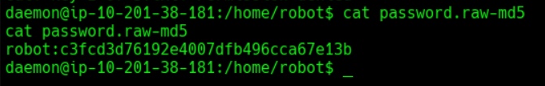
A great tool to use to crack hashes is john the ripper so let’s save the hash value to our local machine and give it to john to crack
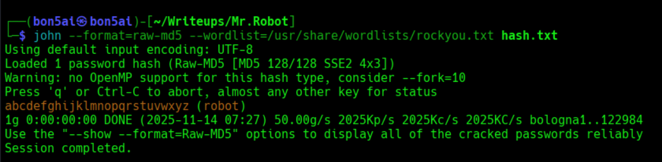
Now we have our cracked username and password
robot:abcdefghijklmnopqrstuvwxyz
Let’s connect via ssh to have a more stable shell to continue with
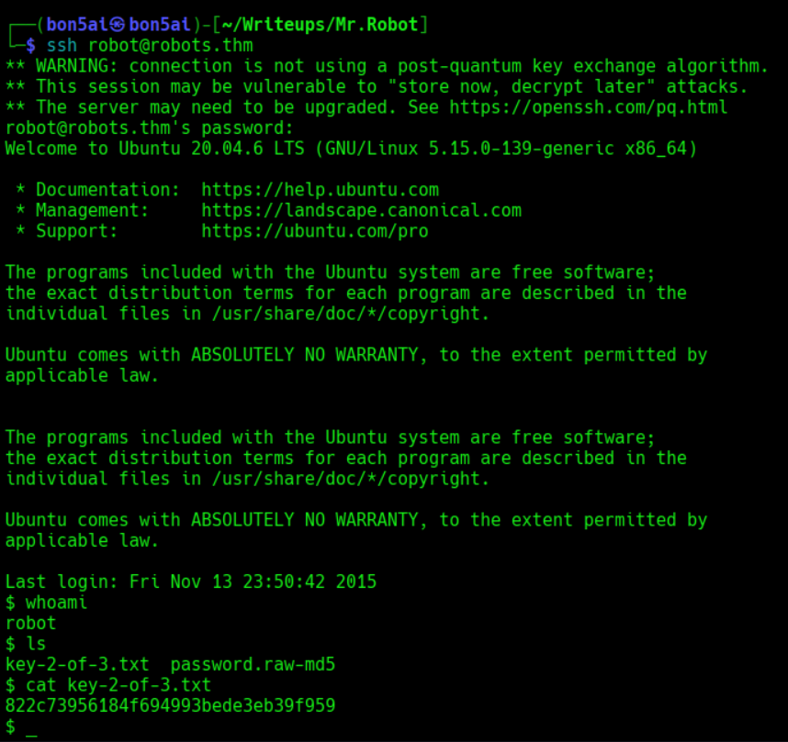
We are now able to view the key-2-of-3.txt file to complete objective 2

Normally the final flag is located in the Root’s home directory which will require some privilege escalation or exploitation to access
Let’s see what we’re able to run as SUDO under the Robot user
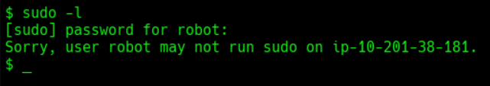
We can’t run sudo on this machine as Robot
Another thing we can check are the SUID permissions
SUID is a special permission that allows a program to run as the file’s owner
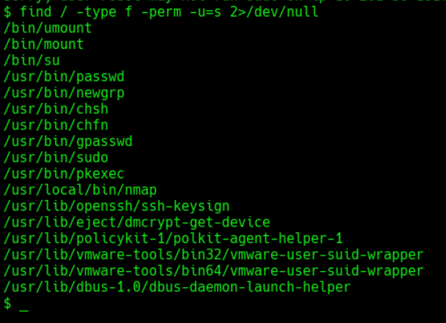
Weird… We can run nmap in the /usr/loca/bin folder. Let’s check the permissions on that
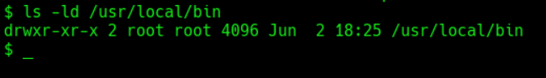
A website I like to use when performing privilege escalation is GTFOBins
If we search for nmap we can see quite a few scripts we can run to exploit these permissions
Link: https://gtfobins.github.io/gtfobins/nmap/
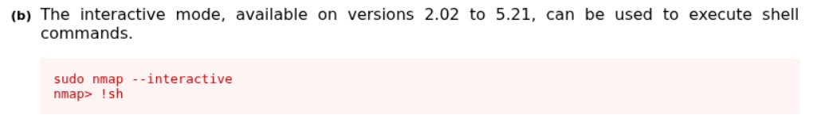
Let’s try to run this without sudo and see if we can get root
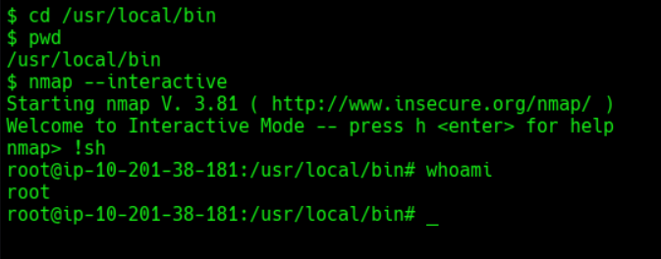
Now we are root!
Let’s check Root’s home directory for the final key
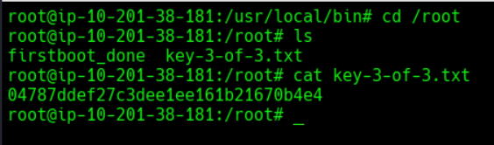
We found the final key to complete objective 3
Room complete!


